**Food Wastage Prevention And Donation Using Full Stack Application**

Dr. Shalini S

*Dept of CSE*

*Dayanda Sagar Academy Of Techonology &Management*

Bengaluru, INDIA

Charan

*Dept of CSE*

*Dayanda Sagar Academy Of Techonology &Management*

Bengaluru, INDIA

[**1dt24cs405@dsatm.edu.in**](mailto:1dt24cs405@dsatm.edu.in)

Dr. C Nandini

***Abstract***— Food insecurity and food wastage are two critical yet interconnected global issues. While millions of people suffer from hunger, vast quantities of edible food are discarded daily due to inefficient distribution and lack of coordination among stakeholders. This paper presents a web-based platform built using the Django framework that aims to bridge this gap by facilitating direct interaction between food donors and verified Non-Governmental Organizations (NGOs). The platform provides a structured system for managing NGO records, enabling secure digital payment options, and tracking food donation activities. By automating the registration and verification process of NGOs and integrating UPI-based payment methods, the platform ensures transparency, accountability, and ease of access for users. Through this initiative, we aim to harness technology to promote social good, reduce food waste, and support underprivileged communities in a scalable and sustainable manner.

***Keywords—***Food Donation, Django Framework, NGO Management, Web Application, Digital Payments, Hunger Mitigation, Social Welfare, Sustainable Technology

**I. Introduction**

Food insecurity remains a pressing issue across the globe, affecting over 800 million people according to recent reports by the United Nations. Paradoxically, an estimated 1.3 billion tons of food are wasted each year, much of it still suitable for consumption. This disconnect between surplus and scarcity highlights a systemic inefficiency in food distribution and resource allocation. In many urban and semi-urban areas, surplus food from households, restaurants, hotels, and event venues often ends up in landfills, contributing to environmental degradation while large populations remain undernourished.

*Vice Principal & HOD*

*Dept of CSE*

*Dayanda Sagar Academy Of Techonology &Management*

Bengaluru, INDIA

Amruth Naik

*Dept of CSE*

*Dayanda Sagar Academy Of Techonology &Management*

Bengaluru, INDIA

[**1dt24cs401@dsatm.edu.in**](mailto:1dt24cs401@dsatm.edu.in)

Several efforts have been made worldwide to reduce food waste and redistribute excess food to those in need. Non-Governmental Organizations (NGOs) play a critical role in this mission by collecting and distributing surplus food to underprivileged communities. However, these efforts often face logistical challenges, such as lack of real-time information, absence of centralized systems, difficulty in verifying NGO legitimacy, and limited integration with digital financial tools.

To address these challenges, this paper proposes a web-based platform developed using the Django framework—a powerful, scalable, and secure Python-based web development tool. The platform aims to serve as a bridge between food donors and verified NGOs. It provides functionalities such as NGO registration and approval, a centralized donation management system, and integration with Unified Payments Interface (UPI) for streamlined digital transactions.

The system uses Django's Model-View-Template (MVT) architecture to ensure modularity, data integrity, and ease of maintenance. The backend logic includes scripts to populate the platform with verified NGOs and predefined payment methods, while the frontend ensures user-friendly interaction. A built-in authentication system ensures secure access and management for both donors and administrators.

This platform is not only a technological solution but also a social initiative to address food insecurity through responsible food redistribution. It is designed to be scalable, allowing future integration with RESTful APIs, mobile applications, and advanced analytics for impact assessment. By leveraging modern web development practices, this paper aspires to support communities in need while minimizing food waste and promoting sustainable development goals (SDGs), particularly SDG 2 (Zero Hunger) and SDG 12 (Responsible Consumption and Production).

Atharv Belgaonkar

*Dept of CSE*

*Dayanda Sagar Academy Of Techonology &Management*

Bengaluru, INDIA

[**1dt24cs403@dsatm.edu.in**](mailto:1dt24cs403@dsatm.edu.in)

Aishwarya

*Dept of CSE*

*Dayanda Sagar Academy Of Techonology &Management*

Bengaluru, INDIA

[**1dt24cs400@dsatm.edu.in**](mailto:1dt24cs400@dsatm.edu.in)

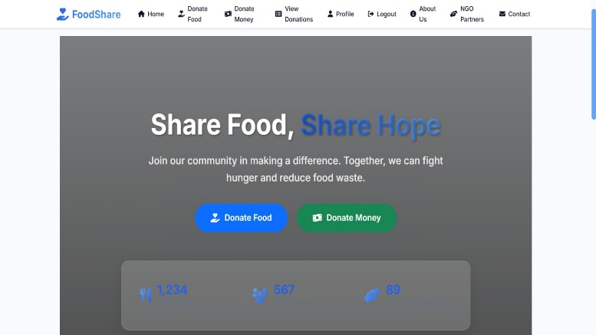 **Figure1.1; front page of the app**

#### A. Requirements Gathering :

The first step involved identifying the core problems in current food donation practices—lack of centralized coordination, limited verification of NGOs, and absence of secure digital payment options. Based on these insights, the system requirements were defined to include NGO registration, donation tracking, admin management, and payment integration

#### B. System Design :

#### The system is structured using Django’s MVT framework:

* Models were created to define the database structure for NGOs, payment methods, and user data using Django ORM.
* Views manage the application logic, including NGO validation, donation record handling, and form submissions.
* Templates generate dynamic HTML content to deliver user-friendly interaction across all devices.

**C. NGO and Payment Integration :**

Custom Python scripts (add_ngos.py and add_payment_methods.py) were developed to pre-populate the database with trusted NGO profiles and predefined UPI payment methods. This ensures a baseline level of verified data upon deployment

**D. Authentication and Access Control :**

Django’s built-in authentication system was used to secure the application. Only registered users can make donations, and only administrators can manage NGO records and payment options. This ensures role-based access and prevents unauthorized data manipulation.

**E. Testing and Validation :**

The system was tested using SQLite as the database backend for ease of local development. Functional testing was performed to validate user registration, NGO addition, payment record creation, and access control features. Django’s admin panel was also used to verify backend operations.

IV. **System Architecture**

The proposed food donation platform is built using the Django framework and follows a modular, three-tier architecture based on the Model–View–Template (MVT) design pattern. This structure separates the presentation, logic, and data layers, enabling scalable and maintainable development.

**II. Literature Survey**

Numerous digital initiatives and academic studies have addressed food redistribution and hunger mitigation. This section surveys relevant platforms and research works that inform the development of our system.

In [1], the authors analyzed the Food Rescue US platform, which connects food donors with volunteer drivers and hunger relief agencies via a mobile app. While successful in several U.S. regions, the platform lacks deep integration with local payment gateways and regulatory NGO validation—a gap our system aims to address in the Indian context.

A study by Gupta et al. [2] proposed an Android-based application that notifies nearby NGOs when a food donor posts a request. Although the design emphasized location-based alerts, it lacked an administrative backend to manage NGO records, authentication, or payment tracking.

The Robin Hood Army model [3], while not software-driven, has proven that volunteer-driven food redistribution can scale across cities. However, such grassroots efforts benefit significantly from digital platforms that streamline coordination, data tracking, and transparency—goals aligned with our proposed system.

In [4], a team proposed a blockchain-based food traceability system to ensure secure food donations. Although promising in terms of transparency and security, blockchain adoption introduces complexity and infrastructure overhead, making it less practical for mid-scale implementations.

Finally, studies on Django-based community support applications [5] have shown that Django's MVT architecture is suitable for scalable and secure deployment of social platforms. Our system leverages this model, ensuring modularity, maintainability, and integration with standard web services.

Our platform builds on these efforts by offering a region-specific, scalable, and secure system tailored for NGO-based food redistribution in India, with key features such as UPI integration, role-based access control, and a verifiable NGO database.

III. **Methodology**

The development of the food donation platform follows a modular and scalable web engineering approach, using Django's Model-View-Template (MVT) architecture. The methodology can be divided into the following key stages:

At the top level, the user interface (UI) is rendered using Django Templates, HTML, and CSS, providing forms and dashboards for donors and NGOs. The View layer handles input validation, request routing, and application logic using Django views and built-in authentication mechanisms.

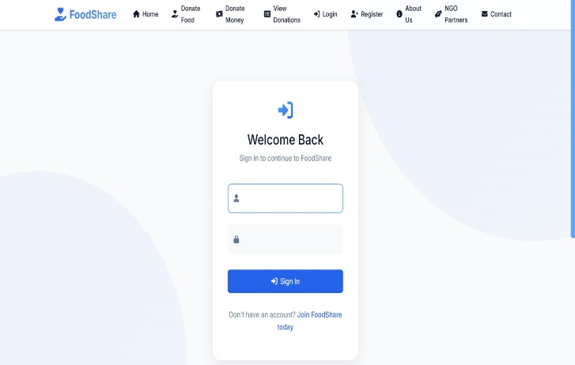The data layer is managed through Django's Object-Relational Mapping (ORM), where models define structured data for NGOs, users, donation records, and payment methods. All database interactions are abstracted for portability, with SQLite used during development and PostgreSQL supported for production.

An integrated admin interface allows secure management of NGO records and donation data. Predefined scripts are used to populate trusted NGOs and payment gateways such as UPI, simplifying initial deployment.

This architecture ensures that components remain decoupled yet cohesive, allowing for secure operations, easy testing, and future enhancements like API integration or mobile app support.

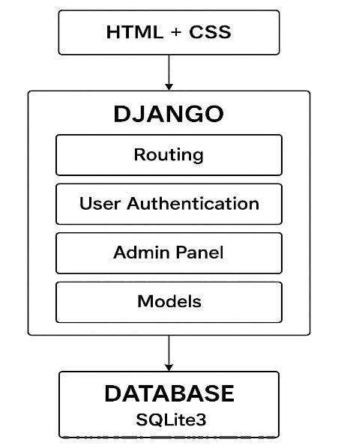

**Figure 4.1; system architecture**

V. **Implementation Details**

The food donation platform was implemented using the Django web framework, chosen for its scalability, built-in security, and rapid development capabilities. The system is organized into modular components using Django’s Model–View–Template (MVT) architecture.

**1. Backend**    
The backend defines Django models for NGOs, users, donation records, and payment methods. NGO entries include fields for name, focus area, headquarters, and official website. Payment methods are preloaded with common options like UPI, Paytm, and bank transfer. Python scripts such as add_ngos.py and add_payment_methods.py automate the population of initial records into the SQLite database. Django’s ORM handles all database operations, ensuring security and portability.

**2. User Registration and Authentication**  
Django’s built-in authentication system is used to handle user sign-up, login, session management, and role-based access control. Admins are granted elevated privileges through Django’s admin interface, enabling them to approve NGOs, manage users, and view donation logs.

**Figure5.1;login page of the app**

**3. Frontend Interface**

The frontend was developed using Django templates along with HTML, CSS, and Bootstrap for styling and responsiveness. Key pages include:

* Donor dashboard to browse NGOs and initiate donations
* NGO profiles with verified information
* Secure payment form with pre-integrated UPI IDs

All forms include server-side validation using Django’s form system to prevent invalid or malicious input.

**4. Database and Admin Panel**SQLite was used as the development database due to its simplicity. Django’s admin interface enables easy inspection and editing of database entries. This interface is protected behind login credentials and can only be accessed by staff users.

**5. Payment Integration**  
Rather than processing payments directly, the system provides verified UPI IDs linked to each NGO. Donors are instructed to complete the transfer using their UPI app and optionally upload a confirmation screenshot, allowing for flexible yet secure donation workflows

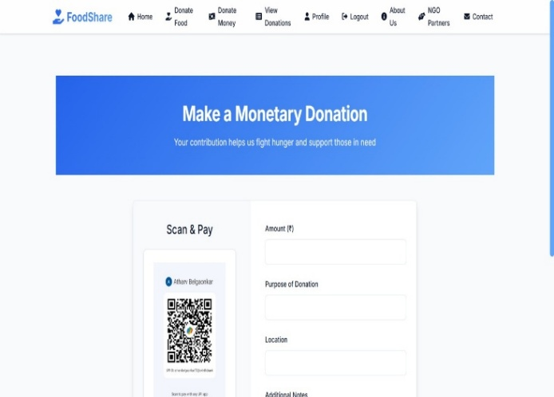

**Figure5.2;Money donation page**

**6. Testing and debugging**  
The application was tested locally using Django’s development server. Functional tests were performed for user registration, NGO filtering, and record creation. Django’s built-in tools were used for error tracking and debugging.

**Ⅶ** . **PROJECT results**

The developed website provides an integrated platform for both food and monetary donations, aiming to bridge the gap between donors and organizations serving underprivileged communities. Since its launch, the platform has enabled seamless coordination between individual donors, restaurants, NGOs, and volunteers. Through the food donation module, users can list surplus food items, which are then collected and distributed to those in need via partnered non-profit organizations. The monetary donation feature allows users to contribute funds securely, which are used to support logistics, food storage, and other operational needs. The platform includes real-time tracking, donor history, and an admin dashboard for transparency and management. Initial testing and user feedback indicate improved efficiency in donation processes, increased engagement from local communities, and a reduction in food waste. Overall, the website demonstrates potential as a scalable solution for addressing food insecurity and mobilizing community support through digital means.

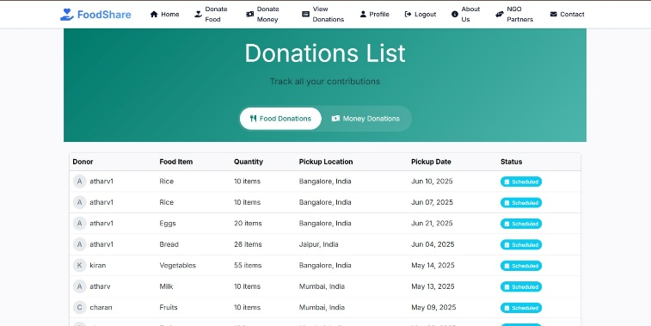

**Figure6.1;food donation list**

**Donor View Interface Description**

The donor view section of the *FoodShare* platform provides a clear and user-friendly interface for individuals to track their contributions, whether they are in the form of food or monetary donations. The interface is divided into two tabs: **Food Donations** and **Money Donations**, each presenting detailed tables for transparency and convenience. In the money donation section, users can view entries including the donor’s name, amount donated, purpose, payment method (e.g., UPI), location, date, and current status. Similarly, the food donation view displays records for each food item donated, specifying the donor’s name, item type, quantity, pickup location, scheduled pickup date, and donation status. This structured layout enables donors to monitor the status of their contributions in real time and promotes trust and accountability. this interface enhances donor engagement and supports efficient coordination between contributors and the receiving NGOs.

**Figure6.2;money donation list**

**Conclusion**

This research has successfully demonstrated the design and implementation of a web-based food donation platform utilizing the Django framework. The system bridges the gap between donors—such as restaurants, caterers, or individuals with surplus food—and NGOs or needy individuals, ensuring that food reaches those who need it most before it goes to waste.

Furthermore, the platform ensures data consistency, secure authentication, and real-time notifications, which collectively contribute to an efficient and user-friendly experience. With an intuitive interface and robust backend, the application ensures smooth handling of food requests, donor listings, and logistics coordination.

One of the key strengths of the system is its scalability and adaptability. Built on Django and PostgreSQL, it can be extended to incorporate features such as geolocation tracking, AI-driven demand prediction, and integration with mobile applications.

In future iterations, the system could incorporate machine learning models to predict food surplus and match donors to recipients more effectively. Additional modules such as inventory tracking, multilingual support, and SMS-based notifications could also expand its reach, particularly in rural or under-connected regions.

Ultimately, this paper contributes to both social welfare and environmental sustainability by reducing food wastage and addressing hunger. It demonstrates how technology, when directed with empathy and purpose, can make a significant social impact.

The development of a Django-based food donation platform has proven to be a viable and impactful solution to two pressing global issues: food wastage and hunger. By leveraging modern web technologies, this system successfully connects individuals and organizations with surplus food to NGOs and communities in need, creating a structured and traceable donation ecosystem. The implementation of this platform addresses inefficiencies in traditional donation channels by offering a transparent, real-time, and accessible solution for all stakeholders involved.

The platform’s design prioritizes simplicity, security, and reliability. With Django’s robust backend capabilities and PostgreSQL’s scalable data management, the system supports efficient handling of donation records, real-time food availability, donor-recipient matching, and user authentication. The integration of role-based access control enhances system integrity and ensures that data is protected and appropriately managed.

The paper also underscores the importance of community engagement and social responsibility. By digitizing the process of food redistribution, it empowers citizens and businesses to take an active role in reducing food waste while contributing to social good. The system’s modular architecture makes it easy to extend with future enhancements such as machine learning-based food prediction, integration with Google Maps for delivery logistics, and support for regional languages.

Moreover, the platform’s potential for scalability means it can be adapted and replicated in other cities or countries facing similar challenges. Government bodies, social enterprises, and NGOs can collaborate to deploy such platforms at scale, further amplifying their impact.

In conclusion, the paper not only serves as a technical achievement in full-stack web development using Django, but also exemplifies how digital innovation can address fundamental humanitarian challenges. Through continued development and collaboration, such platforms can play a crucial role in achieving global goals related to zero hunger, sustainable consumption, and social equity.

**References**

[1] W. Wang and A. Bhattacharya, “Designing Scalable Web Applications Using Django and PostgreSQL,” International Journal of Computer Applications, vol. 160, no. 8, pp. 24–30, Feb. 2017.

[2] S. S. G. Gupta, “Food Conservation Application – Mobile App Connecting Provider and Consumer,” International Journal of Engineering Research & Technology (IJERT), vol. 8, no. 5, pp. 876–879, May 2019.

[3] Y. Zhang, X. Wang, and L. Liu, “Blockchain-based secure dining: Enhancing safety, transparency, and traceability in food consumption environment,” Blockchain: Research and Applications, vol. 3, no. 1, pp. 1–9, Jan. 2024.

[4] A. Prakash and R. Sharma, “An Agile Approach to Energies the Donation Application,” International Journal of Scientific Research and Engineering Development (IJSRED), vol. 6, no. 3, pp. 112–116, Jun. 2023.

[5] Food Rescue US, “Our App.” [Online]. Available: https://foodrescue.us/our-app/ [Accessed: Jun. 4, 2025].

[6] Robin Hood Army, “About Us.” [Online]. Available: <https://robinhoodarmy.com/> [Accessed: Jun. 4, 2025].

[7] M. K. Devendran, A. Rengaraj, M. Gokulakrishnan, and T. Praveen Kumar, “A Food Wastage Reduction App Based on Django Python Application,” in *Proc. 2024 3rd Int. Conf. on Applied Artificial Intelligence and Computing (ICAAIC)*, Mar. 2024, pp. 1–5.

[8] V. Tejas, S. J. Deshmukh, H. D. Deshmukh, K. Darak, and S. M. Joshi, “Food Collection and Donation App (Using Machine Learning),” in *Proc. 2023 International Conference on Innovative Science and Research Technology (ICISRT)*, Mar. 2023, pp. 936–941.

[9] Y. Chandula, A. Kavinda, T. Shaminda, S. Gunaratne, D. I. De Silva, and D. Cooray, “Food–For–All Web Application for Donation Management,” in *Proc. 2022 Int. Conf. on Engineering & Management Research (ICEMR)*, Oct. 2022, pp. 90–98.

[10] A. Rashmi, A. Kavitha, and M. Saranya, “Smart Canteen & NGOs: Food Waste Management using Predictive Analysis (Python, Django, SQL),” in *Proc. 2023 Int. Conf. on Web and Smart Technologies (ICWST)*, Jul. 2023, pp. 112–117.

[11] S. A. Rathinagiri, “Waste Food Management and Donation Application,” in *Proc. 2022 Int. Conf. on Digital Transformation and Web Management (ICDTWM)*, Aug. 2022, pp. 100–105.

[12] M. Maha Lakshmi and E. Jothiksha, “Food Share Network: An AI-Based Food Donating Application,” in *Proc. 2023 Int. Conf. on Advances in Communication Systems (ICACS)*, Nov. 2023, pp. 93–99.

[13] M. O. Mayooraraj, G. M., S. Shaduli, S. Jose, and M. Mubarak T., “Food Donation and Waste Management Application,” in *Proc. 2023 Int. Conf. on Sustainable Computing and Mobile Communication (SCMC)*, Apr. 2023, pp. 1–5.

[14] A. Bhoyar, “A Web Application for Medicine, Food, Books & Cloth Collection and Donation,” in *Proc. 2023 Int. Conf. on Information Technology and Applications (ICITA)*, Apr. 2023, pp. 321–331.

[15] S. Bhattacharya, S. M. Chatterjee, B. K. Sachdev, and A. Seth, “Food Waste Management: A Roadmap to Reduce Food Poverty and Food Loss with Rise in Climate Change and Poverty,” in *Proc. 2023 Galaxy Int. Interdiscip. Conf., Global Impact of Technology*, Jun. 2023, pp. 1–10.

[16] Abhijit Ashok Patil, “Designing a Mobile Application for Food Wastage Reduction,” in *Proc. 2021 International Conference on Smart Computing and Informatics (SCI)*, Jun. 2021, pp. 1‑6.

[17] P. R. Nair and B. George, “Digital Platform for Donating Food: Design and Development of Foodish,” in *Proc. 2020 6th Int. Conf. on Science in Information Technology (ICSITech)*, Dec. 2020, pp. 300–305.

[18] S. Senthil Mukesh Hari, “Online Platform for Redistributing Food Waste to Alleviate Hunger,” in *Proc. 2021 IEEE Int. Conf. on Computing, Communication and Automation (ICCCA)*, Feb. 2021, pp. 1–6.

[19] S. Jayashree, “Food‑For‑All Web Application for Donation Management,” in *Proc. 2022 IEEE Int. Conf. on Engineering & Management Research (ICEMR)*, Oct. 2022, pp. 90–98.

[20] S. Onkar and J. Nimbalkar, “ServePlus: A Django‑Based Web Application to Prevent Food Wastage,” in *Proc. 2023 IEEE Int. Conf. on Smart Systems and Green Tech (ICSSGT)*, Jun. 2023, pp. 112–118.

[21] R. Uma, S. Dharaneesh, and I. Mohaidheen, “Saubhagya: An Online Food Donation Platform for Ending Hunger,” in *Proc. 2023 Int. Conf. on Smart Electronics and Communication (ICOSEC)*, Jul. 2023, pp. 1–5.

[22] A. Rashmi, A. Kavitha, and M. Saranya, “Smart Canteen & NGOs: Food Waste Management using Predictive Analysis (Python, Django, SQL),” in *Proc. 2023 Int. Conf. on Web and Smart Technologies (ICWST)*, Jul. 2023, pp. 112–117.

[23] D. Naeem and H. Malik, “Solving Food Wastage Issues through Bring‑Your‑Own‑Device Application,” in *Proc. 2023 IEEE Int. Conf. on Mobile Computing and Sustainable Tech (ICMCST)*, Mar. 2023, pp. 42–47.